Use the information below to answer questions 1-3.
A grocery store employs cashiers and baggers. Cashiers earn $100 per day and baggers earn $50 per day. The store schedules at most 30 employees per day. The store’s daily payroll for cashiers and baggers cannot exceed $2000.
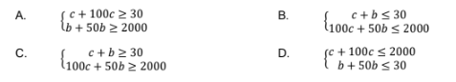
1. Which system of inequalities best describes the possible combinations of cashier and bagger scheduling?

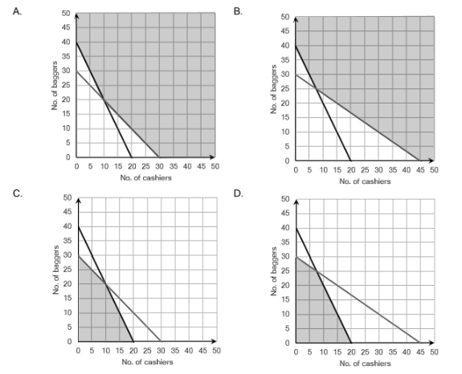
2. Which of the graphed systems best represents this situation?

3. Which of the following statements about the situation is true?

- The store can schedule 10 cashiers and 10 baggers.
- The store can schedule more than 30 people per day.
- The store can schedule 30 cashiers and 10 baggers.
- The store can schedule 25 cashiers and 5 baggers.

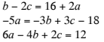
4. What is the solution to the system of linear equations?

- $(5,3,-1)$
- $(5,-1,3)$
- No solution
- Infinitely many solutions

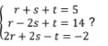

5. What is the solution to the system of linear equations?

- No Solution
- $r=2, s=2, t=-1$
- $r=4, s=-3, t=4$
- Infinitely many solutions

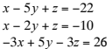
6. What is the solution to the system of equations?

- $(3,4,-3)$
- $(4,-3,-3)$
- Infinitely Many
- No Solution

7. In triangle TUV, the measure of angle U is twice the measure of angle T. The measure of angle V is 80 more than that of T. Formulate the system of equations for this situation.

Equation 1:__________________________________________
Equation 2:__________________________________________
Equation 3:__________________________________________

Use the information below to answer questions 8 and 9.
Customer A spent $18 on a plate of brisket, two sides, and a drink. Customer B spent $10 on a plate of brisket and a drink. Customer C spent $57 on three plates of brisket, six sides, and four drinks.

8. Which augmented matrix best represents the system of linear equations that could be used to determine the price of each item?
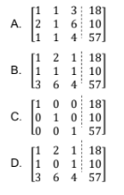
9. What price did the customers pay for a plate of brisket?
- $14
- $7
- $4
- $3

10. A manufacturer of pink erasers has three machines that, when all working, produce 24,000 erasers per day. When only machine A and machine C are operational, they produce 14,400 erasers per day. Together, machine B and machine C produce 18,240 erasers each day.

Which system of linear equations could be used to determine the daily quantity of pink erasers produced by each machine?
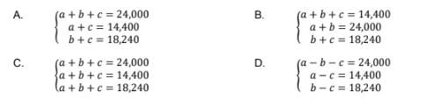

Use the information below to answer questions 11 and 12.
Joy spent a total of $116 on 30 plates, 40 cups, and 4 packages of napkins. Jay spent $1000 on 250 plates, 300 cups, and 50 packages of napkins, while Jon spent $189 on 55 plates, 55 cups, and 6 packages of napkins.

11. Which system of linear equations could be used to determine the price of each type of party supply?

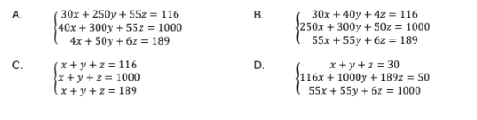

12. Which response best describes the price of each type of party supply?

- Plates cost $2 each, cups cost $1 each, and each package of napkins costs $4.
- Plates cost $30 each, cups cost $40 each, and each package of napkins costs $4.
- Plates cost $1.50 each, cups cost $2.50 each, and each package of napkins costs $5.
- Plates cost $116 each, cups cost $1000 each, and each package of napkins costs $189.

